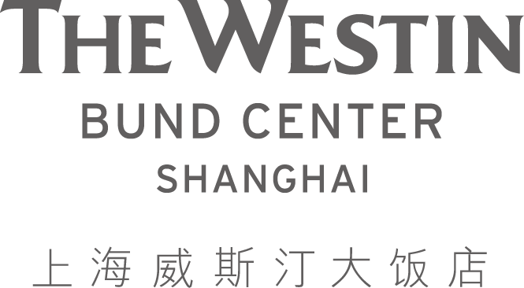

For Immediate Release

CONTACT: | Marina Ma
 | Director of Marketing & Communications
 | Tel: (86 21) 63351888 x 7505
 | Fax: (86 21) 63351794
 | Marina.ma3@westin.com

THE WESTIN BUND CENTER SHANGHAI ANNOUNCES ITS FESTIVE BRUNCH August 2019 WEEKLY BRUNCH THEMES

Shanghai, China - Aug, 2019 - The Westin Bund Center Shanghai announces The Westin Sunday Brunch themes for the month of Aug as follows.

August 4th: Thai Brunch
August 11th: Mexican Brunch
August 18th: Sustainable seafood
August 25th: South American Brunch

In partnership with Veuve Clicquot, The Westin Bund Center Shanghai continues to take its Sunday brunch to a new level. With two floors of food extravaganza (with weekly brunch themes throughout the year), free-flowing Veuve Clicquot champagne, a wine buffet, a ‘make-your-own’ cocktail bar and a myriad of entertainers.

Recently included in CNN.com Travel's '50 reasons why Shanghai is the world’s greatest city', The Westin Sunday Brunch is definitely an event not to be missed.

About The Westin Sunday Brunch
Each Sunday, guests gather around Heavenlies lounge and The Stage restaurant on the ground floor and Prego Italian Restaurant on the second floor to witness awe-inspiring acts of acrobatic feats, clowns and mesmerizing acrobatic performance while listening to an astounding fourteen piece string orchestra with soprano and alto performing all-time favorite arias. The atmosphere that The Westin Bund Center Shanghai creates adds to the hotel’s brunch motto of “Let us entertain you”.

To assure the little ones enjoy the brunch just as much as the adults, a Kid’s Corner with on-site nanny, toys, cartoons, games and food is available. Guests also get to walk away with several kinds of food vouchers at the brunch’s lucky draw and can purchase additional bottles of Veuve Clicquot champagne at a special price.

Time: 11:30AM – 2:30PM
Price: RMB 695 per person (adult) with free-flowing champagne
RMB 578 per person (adult) without free-flowing champagne and
alcoholic beverages
RMB 308 per person (child)
Kids under four years old dine for free.

Venue: The Stage, Lobby Level, or Prego, Level Two at The Westin Bund Center Shanghai at 88 Henan Zhong Lu, Near Guangdong Lu.
For details and reservations, please contact Dining Reservations at (021) 6103-5048, e-mail: shanghai.restaurants@westin.com

About The Hotel
Just a stroll away is the magnificent Bund architectural site and waterfront. Yu garden, a 400-year-old classical Chinese garden and the popular pedestrian shopping precinct on Nanjing Road are also within short walking distance. Lujiazhui Financial District is a mere 10-minute taxi ride away. With 557 tastefully-decorated guest rooms and suites offered in two towers, other services and facilities include restaurants serving Chinese, Italian and international favorites including the city’s famous Sunday Brunch and a Westin Workout fitness centre with indoor swimming pool and iSpa.
The Westin Bund Center Shanghai is located at 88 Henan Middle Road, Shanghai 200002, China. Tel: (86 21) 6335 1888. Website: http://www.westinshanghai.com
# # #

